CMSC 204

Huffman Lab

1. Create a Huffman Tree and generate the codes for each character of the following input:

create a huffman tree

c : 1

r : 2

e : 4

a : 3

t : 2

h : 1

u : 1

f : 2

m : 1

n : 1

“ “ : 3

c : 1, h : 1, m : 1, n : 1, u : 1

f : 2, r : 2, t : 2

“ “ : 3, a : 3

e : 4

c : 1, h : 1, m : 1, n : 1, u : 1, f : 2, r : 2, t : 2, “ “ : 3, a : 3, e : 4

For consistency:

1. If same frequency – put in priority queue alphabetically; put space before other characters of the same frequency
2. Add subtrees to end of group with same priority
3. Lower number has higher priority (goes to front)

Now encode “create a huffman tree”

111001100101001110110100000100011101100010011001111100011111100011011100101101

1. Based on the following Huffman tree and binary sequence, what is the text

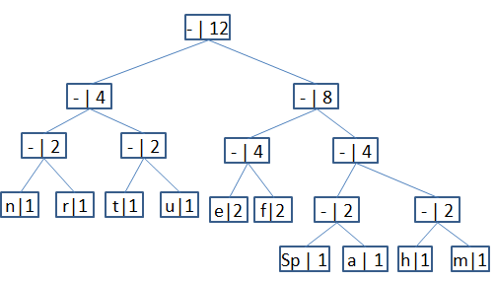

1110 011 101 101 1111 1101 000 1100 010 001 100 100

huffman tree